STANDING RULES
OF
THE PRESBYTERY OF THE
MISSISSIPPI VALLEY

- ARTICLE I: NAME

The name of this presbytery shall be, "The Presbytery of the Mississippi Valley."

- ARTICLE II: MEETINGS

A. STATED MEETINGS:

Four stated meetings shall be held each year, convening at nine o'clock A.M. on the first Tuesday in February, May, August and November.

B. ADJOURNED MEETINGS:

Adjourned meetings of stated meetings may be held as deemed advisable. Matters for consideration at an adjourned meeting shall be those which would have been considered at the previous stated meeting.

C. CALLED MEETINGS:

Called meetings may be held when necessary as provided in BCO 13-1. Ordinarily examinations shall not be handled at called meetings.

- ARTICLE III: PROCEDURES FOR MEETINGS

A. QUORUM:

The quorum of all meetings shall be three ministers and three ruling elders, as set forth in BCO 13-4.

B. RULES OF ORDER:

- Operating Rules:
The rules contained in the current edition of Roberts Rules of Order shall be the parliamentary authority governing the presbytery, provided they are not inconsistent with the constitution of the Presbyterian Church in America or any standing rules the presbytery may adopt.

- Suspension of Rules:
The Standing Rules may be suspended upon motion by an affirmative vote of two-thirds of the registered commissioners.

- Amendment of Rules:
The Standing Rules may be amended by an affirmative vote of two-thirds of the representatives present and voting at two successive stated meetings of presbytery.

C. THE DOCKET:

1. Preparation, Adoption and Amendment:
A proposed docket setting forth the order of business shall be prepared by the stated clerk for stated meetings. A docket shall be adopted by a majority vote and may be amended at any time during the meeting by a majority vote.

2. Regularly scheduled business:

a. The permanent committees' stated reports will be docketed no later than 10:30 A.M. of the meetings to which they are to report as listed in Article VII,D,1,g.

b. The presbytery will docket at least 15 minutes for corporate prayer during the meeting of presbytery, preferably during the morning session.

c. The retiring moderator's sermon shall be docketed at 11:15 A.M. as the last order of business before lunch.

d. The Credentials Committee report shall be docketed no later than 1 P.M.

3. Special Guests:
Committee chairmen wishing to present special speakers at a stated or adjourned meeting of presbytery should consult the stated clerk prior to presbytery's meeting before making any arrangements.

D. DEADLINES FOR STATED MEETINGS:

All overtures and reports of permanent and special committees must be furnished to the stated clerk at least four weeks prior to a stated meeting if they are expected to be in the White Book.

E. WHITE BOOKS:

1. Preparation:
The stated clerk shall prepare and send out a White Book containing the proposed docket, committee reports, and all overtures for each stated meeting.

2. Distribution:
The White Book is to be distributed two weeks prior to each stated meeting. Sufficient copies shall be sent to each clerk of session for himself and that church's representatives and to each minister enrolled in presbytery.

F. SPECIAL OBSERVANCES:

1. The Lord's Supper:
The sacrament of the Lord's Supper shall be observed at the February and August stated meeting, following the sermon. The retiring moderator shall be responsible for the communion service, appointing ministers and ruling elders to assist in the service as he deems suitable.

2. Memorials:
Ruling elders who have died during the past year shall be memorialized at either the February or August stated meetings. A special page of the minutes shall be devoted to their memory, with the names of the elders, their churches, and the dates of their deaths being given. A minister who has died shall be memorialized at the next stated meeting following his death. A page in the minutes shall be set apart for a brief account of his life and work. Memorials at the February and August stated meetings should ordinarily be observed in connection with the communion service. The moderator, or in his absence, the stated clerk, shall arrange for a proper memorial paper to be presented to the presbytery.

G. ATTENDANCE:

1. Duty:
Members of presbytery are expected to attend every meeting, to arrive on time, and to attend all sessions. Every church session should be represented at each meeting.

2. Excuses:
When providentially hindered from attendance, a minister or session representative is expected to request presbytery to excuse him, stating his reason for his absence.

3. Yearly Ministerial Reports:
Ministers laboring out of bounds of presbytery or without call, excepting those honorably retired or permanently disabled, are expected to report at each August stated meeting concerning their locations and activities.

H. PLACE OF MEETINGS:

Presbytery may accept invitations for future meetings at any stated meeting. If no invitation is presented for the next stated meeting, the moderator and stated clerk shall undertake to secure an invitation or designate a place of meeting.

I. ELECTRONIC MEETINGS:

A special meeting of Presbytery, of Presbytery’s subordinate commissions, or of Presbytery’s subordinate committees may be conducted by teleconference or videoconference, provided that:

- The meeting does not conduct any of the following kinds of business: (a) the gathering of
evidence; (b) deliberation of guilt or innocence, or © deliberation of a censure.

- A meeting conducted by teleconference or videoconference shall employ technical means that ensure that all persons participating in the meeting can contemporaneously hear each speaker and be heard by all other participants.

3. In a meeting conducted by teleconference or videoconference, a participant shall seek the floor by announcing his name and church affiliation or by sending an electronic message to the chair of the meeting. The chair will be responsible for keeping a list in order of participants who seek the floor. The chair of the meeting shall recognize a speaker by name, at which time the speaker will then have the floor. Participants shall take care to avoid speaking at the same time. Participants shall not converse with each other while another has the floor.

- ARTICLE IV: CHURCH RELATIONS

A. PRESBYTERY'S POSITION ON PROPERTIES OF CONGREGATIONS:

This presbytery declares that it does not have nor will ever have an interest or claim upon the real properties and the personal properties of the constituent congregations. Such properties will remain with the control and management and ownership of the membership of those congregations. The presbytery may receive monies or properties from a local church only by free and voluntary action of the latter. The presbytery shall never claim the right to determine who is the congregation in matters regarding property (BCO 25-8,11,12).

B. SESSIONAL RECORDS:

The bound, official recordings of the proceedings of each church session shall be submitted annually for inspection of the presbytery (BCO 12-7) at the May stated meeting. If possible, the records for the previous year should be submitted via electronic means to the chairman of the Records and Archives Subcommittee by January 31. All churches who are unable to submit their records electronically shall bring to presbytery two (2) copies for examination by the Records Sub-Committee to the February stated meeting of presbytery. The chairman will report at the February meeting of presbytery which sessions have not submitted their minutes for review.

C. PROCEDURES FOR SECURING A STATED OR STUDENT SUPPLY:

Sessions desiring to have a minister, a student preparing for the ministry, or a ruling elder fill their pulpit more than once a month on a regular basis must request approval for a supply relationship from the presbytery. Preliminary approval may be granted by the Credentials Committee for members of Mississippi Valley Presbytery or for other men who have been examined by the committee. No man may fill a pulpit more than once a month on a regular basis in any church in the presbytery without meeting with the Credentials Committee.

D. ANNUAL REPORTS:

Sessions shall prepare annual reports to the presbytery upon blanks provided by the stated clerk of the General Assembly. Those reports should be presented to the stated clerk of presbytery no later than four weeks before the February stated meeting. The stated clerk shall inform presbytery which sessions have not submitted reports.

E. ASKINGS:
Churches are requested to provide their portion of the presbytery's budget by contributing the "Askings" requested (see ARTICLE VIII). Churches should remember that presbytery's budget includes personal support and projects which demand monthly disbursement. Proportionate payments, if possible, should be made beginning at the first of the year toward meeting the Askings.

- ARTICLE V: MINISTERIAL RELATIONS AND PROCEDURES

A. COVENANTS:

1. Each minister received into the presbytery, and each candidate approved for ordination, shall subscribe his name to the obligation signed by all the ministers on the day of the formation of this presbytery.

2. Such subscriptions shall be kept in a book or file by the stated clerk as part of the records of the presbytery.

B. ESTABLISHMENT AND DISSOLUTION OF MINISTERIAL RELATIONS:

1. Transfer from another PCA presbytery:
An ordained minister from another presbytery shall not move onto the field without examination and approval of the terms of the call by the Credentials Committee.

2. Transfer from another denomination:
An ordained minister from another denomination may not move onto the field without examination and approval by the Credentials Committee and the presbytery.

3. Transfer within presbytery:
A member of presbytery receiving a call within the presbytery itself may move onto a new field of service with the approval of the terms of call and permission of the Credentials Committee.

4. Approval of presbytery required:
Whenever a man is permitted to move onto a field of service in the presbytery, it must be fully understood by the minister and congregation that the approval of a committee does not suspend the need for the approval of the presbytery as a whole, and that temporary permission granted by a committee may be overruled by the presbytery.

- ARTICLE VI: OFFICERS OF PRESBYTERY

A. OFFICERS:

This presbytery shall have five officers--the moderator, the stated clerk, the recording clerk, the treasurer and the parliamentarian.

B. ELECTIONS:

A moderator shall be elected to preside at each stated meeting, while other officers shall be elected for three years. Officers shall be elected at the February stated meeting and shall serve until their successors are elected. Vacancies may be filled at any meeting of presbytery.

C. RESPONSIBILITIES:

1. Moderator:

The moderator shall preside over all business conducted at each meeting of presbytery. He shall have authority to replace men on ordaining and installing commissions who are not able to serve. He shall serve on the Program Committee, assisting the stated clerk in the preparation of the docket for the next stated meeting. Presbytery, at each stated meeting, shall also designate a "first nominee" for this office for the next stated meeting.

2. Stated Clerk:

a. Duties:
The duties of the stated clerk shall be those ordinarily expected of this office (BCO 10-4), especially those concerned with the preparation of the docket for each stated meeting, the proper recording of proceedings, the printing of the minutes after the end of each calendar year, and the careful preservation of the minutes and other valuable records of the presbytery. He shall ordinarily attend the meeting of the General Assembly.

b. Remuneration:
The salary and office/travel expense allowances shall be determined annually by presbytery.

3. Recording Clerk:

a. Duties:
The recording clerk shall take the record of meetings, assist the stated clerk in putting minutes together for printing, and in general assist the stated clerk in his duties.

b. Remuneration:
The salary and office/travel expense allowances shall be determined annually by presbytery.

4. Treasurer:

a. Duties:
The treasurer shall receive and disburse all funds according to ARTICLE VIII, prepare a yearly budget for presbytery expenses to be presented to the Administration Committee, submit required financial reports to the presbytery (see below) and serve as a member of the Administration Committee and its Stewardship and Finance Sub-committee.

b. Bonding:
The treasurer shall be bonded in the amount designated by the presbytery. Premiums shall be paid by the presbytery.

c. Reports:
A financial statement showing receipts, disbursements and presbytery's current financial status shall be submitted in the White book to each stated meeting of presbytery.

d. Remuneration:
The salary and office/travel expense allowances shall be determined annually by presbytery.

5. Parliamentarian:

a. Duties:
To assist the moderator and the stated clerk with advice concerning the BCO and Robert’s Rules of Order for the proper administration of presbytery meetings.

b. Remuneration:
The salary and office/travel expense allowances shall be determined annually by presbytery.

- ARTICLE VII: COMMITTEES

A. TYPES:

1. Regular committees:
There are three types of committees: permanent, standing, and special.

2. Multi-presbytery committees:
Multi-presbytery committees which are set up for the oversight and promotion of ministries shared by more than one presbytery shall always come under the responsibility of a particular permanent committee. Such responsibility shall include appointing members to these committees, financial appropriations, and regular reports to presbytery.

B. QUORUM:

The quorum for a committee or a commission shall be one more than one half its membership.

C. FINANCIAL AUTHORITY:

A committee is authorized to reallocate funds within the presbytery approved total to other presbytery approved works for that committee. The committees will report such changes to presbytery for approval at the next stated meeting.

D. ORGANIZATION:

1. Permanent Committees:

a. Committees:
The permanent committees are Administration, Campus Ministry Committee, Discipleship Ministries, Credentials, Mission to the U.S. Military and Chaplains, Mission to North America, Mission to the World, Nominations, and Shepherding and Advisory.

b. Nominations:
Nominees will be presented by the Nominations Committee at the November stated meeting. The floor will then be open to receive other nominees. However, the Nominations Committee will not present nominees for its committee; those names will be received only from the floor.

c. Elections:
Members for permanent committees shall be elected at the November stated meeting. Those elected shall assume their duties immediately upon being elected and serve until their successors are chosen. As far as possible, ministers and ruling elders should have equal representation on these committees. Vacancies on any of the committees may be filled at any meeting of presbytery upon recommendation of the nominating committee.

d. Terms:
Members of the permanent committees shall be elected for three years. They shall serve in three yearly classes of equal number according to the size of each committee. Committee members may serve no more than two consecutive terms before a lapse of one year. A member filling an unexpired term is eligible for re-election to a full term.

e. Convener:
If a committee is at any time without a chairman, the stated clerk shall appoint a convener to see that the committee is convened, elects a chairman, and carries out its responsibilities.

f. Minutes:
The chairman is responsible to see that a copy of the approved minutes for each committee meeting is sent to the stated clerk for permanent filing. Committee reports with recommendations to be presented to presbytery for approval and the minutes of meetings are to record the committee votes. A brief explanation of negative votes shall be provided by the committee upon request of those that dissent.

g. Committee Reports:
Each committee is to report to presbytery according to the following schedule. Supplemental reports for other meetings may be submitted as each committee deems necessary. The committee chairman of any committee scheduled or seeking a place on the docket must submit the committee report to the stated clerk in time for inclusion in the White Book.

Committees Time of Reporting
Administration Each meeting as needed
Campus Ministry February
Discipleship Ministries November
Credentials Each Meeting as needed
Mission to the U.S. Military May
Mission to North America May
Mission to the World May
Nominations February and November
Shepherding and Advisory August and as needed

h. Strategic Goals:
Each permanent committee is to implement presbytery’s strategic goals as spelled out in Appendix G and provide an annual evaluation of committee progress to the presbytery and the Administration Committee.

i. Alternate Members:
Each permanent committee shall have two alternate members. Alternate members are expected to attend every stated meeting, called meeting and meetings ordered by presbytery unless providentially unable to attend. The alternates shall be non-voting members except when filling an unexpired term of a permanent member or appointed by the committee chairman to serve in place of a permanent member who is providentially unable to attend.

2. Standing Committees:

a. Committees:
At a stated meeting the moderator shall appoint standing committees to consider and report on any matter requiring attention at that meeting of presbytery. The standing committees are as follows:

(1) Overtures: as needed with the immediate past moderator as chairman. (2) Thanks: each meeting.
(3) Judicial Business: as needed.

b. Size:
Standing committees shall consist of three members each with the chairman named by the moderator.

3. Special Committees:

a. Program Committee:
The Program Committee shall assist the stated clerk in the preparation of the docket for the upcoming stated meeting. It shall consist of the moderator, the stated clerk, the first nominee for moderator, permanent committee chairmen and the pastor or a ruling elder of the church that is to host presbytery.

b. New Committees:
Other special committees may be established as the presbytery deems advisable. Such committees shall always be given a specific purpose and a deadline to complete business. Special committees shall not ordinarily be included in the Standing Rules.

- Procedures Committee:
    - Number: This committee shall consist of six members – the Officers of this Presbytery (Article VI.A.) and the previous moderator of this Presbytery.
    - Business: The Procedures Committee shall consider and make recommendation concerning the administrative procedures for all Cases of, or Without Process (BCO 31; 32; 34; and 38), References (BCO 41), Appeals (BCO 42), and Complaints (BCO 43) submitted to the Presbytery.

E. RESPONSIBILITIES

1. Administration Committee:

a. Number:
The Administration Committee shall consist of twelve members, and two alternates. The stated clerk and the treasurer shall serve as ex officio members.

b. Organization:
The committee will elect its own chairman. The chairman will assign sub-committee chairmen and two members to each of four sub-committees: Communications, Records & Archives, Rules, and Stewardship & Finance. In addition to the other sub-committee members, the stated clerk shall serve on the Communications and Rules Sub-committees. The treasurer shall serve as an additional member of the Stewardship and Finance Sub-committee.

c. Business:
The Administration Committee shall: report on any recommended changes to our Standing Rules, review sessional records, preserve historical documents and histories, handle communications, make public announcements, establish and oversee the use of media for the promoting of the gospel and presbytery ministries, recommend the annual presbytery budget, promote both presbytery and PCA per capita askings among member churches, communicate with member churches of presbytery’s work, compile an annual review of the progress toward the fulfilling of presbytery’s strategic plan, initiate reevaluation and updating of our strategic plan in cooperation with the committee chairmen, assist in matters related to the work of the stated clerk as requested.

To accomplish these tasks the following sub-committees shall report to the whole committee on the following tasks:
1) Communications Sub-committee:
a) assist the clerk with communications between presbytery, our churches, and the PCA,
b) make public announcements on behalf of presbytery,
c) establish and oversee the use of media for the promoting of the gospel and presbytery ministries including but not limited to the Web and Radio/TV programs or advertisements.

2) Records & Archives Sub-committee:
a) handle the review of sessional records at the February and subsequent meetings as necessary. (Presbytery shall resolve itself into a committee-of-the-whole as needed to accomplish this task.),
b) evaluate each Session's records of its proceedings noting any exception of form or of substance not in compliance with the Book of Church Order. A report will be presented to the Administration Committee and thus presented to presbytery for their approval.
c) prepare reviewed session books for the moderator's signature,
d) preserve copies of evaluation forms for committee evaluation and reporting,
e) prepare an annual evaluation of presbytery’s progress in achieving strategic goals with a record of the advancement of our churches in meeting strategic goals.
f) initiate an assessment and rewriting of our strategic goals every five years.

3) Rules Sub-committee:
a) review proposed changes to the Standing Rules,
(This review should, if changes are submitted in a timely manner, be given at the first reading, but must be completed before the second reading and final vote of the presbytery. In reviewing proposed changes, this sub-committee is to consider the logical relationship of proposals to the overall Standing Rules, consider alternatives that would accomplish the intended purposes of the recommendations, and submit opinions as to the advisability of the recommended changes.)
b) provide appropriate BCO corrections to our Standing Rules, c) assist in matters related to the stated clerk’s work as needed.

4) Stewardship & Finance Sub-committee:
a) review presbytery expenditures as reported by the treasurer, b) prepare an annual presbytery budget,
c) communicate needed “per member askings” to meet our budget and encourage stewardship for presbytery and denominational askings,
d) handle requests for special expenditures by committees,
e) make arrangements for an audit or review by a qualified individual when deemed necessary,
f) assist the treasurer in his work and responsibilities.

2. Campus Ministry Committee:

a. Number:
This committee shall consist of nine members and two alternates.

b. Business:

1. The committee will appoint four members to serve on the Mississippi Joint Committee on Campus Work (MJCCW).

2. The committee, in conjunction with the MJCCW, will manage administration related to campus work (e.g. salaries, staffing, new campuses).

3. The committee will give pastoral oversight for campus works within the bounds of presbytery.

3. Credentials Committee:

a. Number:
This committee shall consist of twelve members and two alternates.

b. Business:
1) This committee shall be responsible for supervision of candidates, licentiates, and interns.
2) The chairman shall be elected by the committee and shall assign one member to lead in oral examinations in each of the following categories: experiential religion, theology, sacraments and church government, and English Bible. Further examination may be conducted by any member of the committee. Also, the chairman shall appoint one member to evaluate sermons, written papers, and transcripts, and to evaluate the applicant's seminary training according to the uniform curriculum as directed in APPENDIX A, 6.
3) This committee shall examine all applicants for candidacy, licensure, and ordination, as well as all ministers seeking admission to presbytery. Men seeking chaplaincy or transferring in as chaplains will always come by way of the recommendation of the Mission to the Military committee. Before presenting men to the presbytery, the committee shall conduct examinations as follows:
a) Candidates for licensure and ordination, as well as transferring ministers, shall submit written explanations of their theological views for the study of the whole committee. Forms shall be provided by the chairman.
b) Candidates for licensure and ordination must complete committee administered written examinations. Licensure examinations will include basic knowledge of theology, English Bible, and church government. Written exams for ordination are to be appropriately thorough for those entering the gospel ministry. They are to cover English Bible, church government, church history, PCA history, and the sacraments.
c) Oral examinations for each applicant shall be conducted and shall include experiential religion and call to the ministry. Transferring ministers and applicants for ordination shall be examined orally and extensively in theology and in any area of weakness indicated in their written examinations. Oral examinations for licensure shall deal briefly with theology, English Bible, and church government, with emphasis placed upon areas of weaknesses indicated in written examinations.
d) Candidates for licensure, ordination, or transfer with any difficulty or disagreement with any part of the confessional standards shall make it known to the Credentials Committee. The committee shall take care that all expressions of difficulty or disagreement with our confessional standards are presented to the presbytery in writing and explained to the presbytery’s satisfaction. It should be noted that the presbytery, not the examinee, determines what is or is not an exception to the confessional standards.
4) The committee will examine candidates briefly on the floor of presbytery, with representative questions covering all areas of required examination. Any areas of weakness exposed in either written or oral examinations before the committee shall be reported to the presbytery before the examination begins. The floor will then be open for any member of presbytery to question the candidates.
5) It shall also be the duty of the committee to give an examination to any man desiring to serve as stated supply or student supply. This committee is authorized to grant permission for a man to move onto the field prior to the presbytery's approval of his licensure or ordination examination (see BCO 21-1).
6) The committee shall keep a roll of candidates, licentiates, and interns, maintaining communication with them and oversight over them according to BCO 19. The committee may transfer candidates, licentiates, and interns to other presbyteries or denominations upon their written requests when all proper procedures are in order. The Credentials Committee is clothed with the powers of a commission for such transfers.
7) The chairman shall appoint three members to each of two sub-committees; one will supervise candidates and licentiates, while the other will supervise interns.
8) The Credentials Committee shall review the terms of call for ministers transferring within or seeking admission to the presbytery.
9) In response to an organization’s request which is in keeping with BCO 8-7 for a man to labor out-of-bounds, an official ecclesiastical call will be drafted by the committee for presbytery to issue to the man, so that standards of the Book of Church Order are met and the relevant issues arising from U.S. tax law are noted.

4. Discipleship Ministries Committee:

a. Number:
This committee shall consist of nine members and two alternates.

b. Business:
1) The responsibility of this committee is to promote the work of Christian education and discipleship among the churches of presbytery.
2) The committee shall organize, support, promote, and administer seminars for the education and training of church leaders.
3) It is the duty of this committee to assist and encourage the work of youth and children’s ministry within the presbytery.
4) It is the duty of this committee to assist, encourage, and oversee the work of the Presbytery Women’s Ministry. The yearly report of the Presbytery Women’s Ministry is to be included in this committee’s annual report.

5. Mission to the U.S. Military and Chaplains:

a. Number
This committee shall consist of six members and two alternates

b. Business:
1) This committee shall be responsible for MVP involvement in coordinating and overseeing the planting of PCA churches and development of university ministries near U.S. military bases and academies in foreign countries and within the U.S. while working with and recognizing the bounds and jurisdiction of other presbyteries and church courts.
2) Determine the nature of financial support for the church planter of such a congregation.
3) This committee shall ensure adequate insurance coverage for such persons that are supported and sent by the presbytery.
4) Assist candidates for chaplaincy with the candidating process leading to and including a call.
a) The committee shall keep a roll of chaplain candidates.
b) The committee shall pray for and assist all those interested in pursuing military chaplaincy within our presbytery with our presbytery process.
c) Candidates pursuing chaplaincy must be interviewed and examined by the Mission to the Military committee prior to being examined for presbytery candidacy by the Credentials Committee and presbytery.
d) Chaplains transferring into the presbytery must meet and be recommend by this committee before being examined by the Credentials Committee.
e) Any areas of weakness exposed in the interviews or examination shall be reported to the Credentials Committee and to the presbytery before their examinations begin.
f) The committee shall pray for and maintain regular communications with all our presbytery chaplain candidates.
5) Oversee and support MVP chaplains.
6) Coordinate relationships with similar committees in other PCA presbyteries.
7) Promoting MVP church plants to the military and encouraging prayer
and service in this ministry.

6. Mission to North America Committee:

a. Number:
This committee shall consist of twelve members and two alternates.

b. Business:
1) This committee shall promote and encourage the growth of the church within the geographical bounds of presbytery.
2) It shall encourage, oversee, and coordinate the planting of mission churches within the bounds of presbytery. Such efforts must, when appropriate, follow the guidelines found in Appendix B -- "Guidelines for Churches with Dissenting Members." Monetary support may be appropriated to new works from the committee's approved funds.
3) This committee shall nominate men to serve on borrowed sessions for mission churches. Approval must be given by presbytery.
4) The oversight of aid to existing congregations shall be the responsibility of this committee. All decisions to support or discontinue support to a particular church shall be reported at the next presbytery meeting.
5) The MNA committee shall oversee the coordination of mercy ministries within the bounds of presbytery and provide for cooperation with the General Assembly's mercy ministry program. The committee also shall be responsible to oversee presbytery's participation on the Advisory Board of Lifeline Christian Services. This includes the responsibility to:
a) Appoint one MNA committee member to serve on the Advisory board and to act as liaison between the board and the MNA committee.
b) Provide for reporting about the work of this board to presbytery at the May meeting.
c) Appropriate monies as the committee desires to support the work of Lifeline.

6) The MNA Committee shall establish a Deaconal Ministries Sub-committee made up of six deacons of MVP congregations and two regular members of the MNA committee to plan, promote and resource mercy ministry within our presbytery.

7) This committee may recommend presbytery certification of ministries whose purpose is to minister the Gospel among people groups or within institutions who work within the bounds of presbytery, but who are not ordinarily accessible to particular churches or other ministries of the presbytery. Such certification may be established by vote of the presbytery upon the recommendation of the MNA committee. Once established, the certification shall continue until terminated by vote of the presbytery.
a) Benefits to the certified ministry:
1) The ministry is commended to the churches of the presbytery for their participation and for prayer and financial support.
2) The ministry may include notice of the relationship in its printed materials and presentations.
3) The MNA committee may recommend the certified ministry to the General Assembly or other institutions or accrediting agencies as appropriate.
b) Requirements of the certified ministry:
1) A statement of faith required of staff and board members which affirms, or is compatible with, the historic reformed standards.
2) Supply to the MNA committee basic founding documents, such as constitution, by-laws.
3) Supply to the MNA committee regular newsletter or other similar communications.
4) The MNA committee shall annually review board minutes, board policy changes and management of finances.
5) The MNA committee shall establish a direct relationship between the MNA committee and the board of the certified ministry for the purposes of ongoing accountability and communications.

7. Mission to the World Committee:

a. Number:
This committee shall consist of nine members.

b. Business:
1) This committee is to promote the importance of world missions among the churches in our presbytery.
2) This committee is to elicit funds for first term missionaries and to recommend distribution of such funds. Also, it may recommend distribution of funds received from the presbytery budget to first term missionaries.
3) The committee is to gather current information from the world's mission fields and distribute it among the churches of the presbytery.
4) The committee is to strengthen and maintain relationships with the Mission to the World Committee of the General Assembly in order to promote its work in presbytery.
5) For the better coordination of mission efforts, the committee is to strengthen and maintain relationships with local church missions committees and to help establish such committees where needed.
6) This committee shall be empowered and directed to provide insurance coverage for such persons that are supported and sent by the presbytery.

8. Nominations Committee:

a. Number:
This committee shall consist of six members and two alternates.

b. Business:
1) This committee shall nominate presbytery representatives for the General Assembly Nominations Committee, permanent committees, and agencies at the November stated meeting; and it shall nominate presbytery commissioners for the General Assembly committees of commissioners at the February stated meeting.
2) This committee shall submit yearly nominations for all expired terms and resignations of the permanent committees. Nominees are to be submitted at the November stated meeting and when necessary.
3) This committee is responsible to provide the stated clerk with the phone numbers and addresses of all nominees. They should be submitted to him no later than four weeks prior to presbytery's meeting.

9. Shepherding and Advisory Committee:

a. Number:
The Shepherding and Advisory Committee shall consist of twelve voting members and two alternates. The stated clerk shall serve as a non-voting member.

b. Business:
1) The Shepherding and Advisory Committee should consult with a church when: a) it continues without a pastor or a stated supply arrangement;
b) it could call a pastor but continues to depend upon a stated supply arrangement;
c) either the church or the pastor contests the dissolution of the pastoral relationship (see Appendix C);
d) dissension within the congregation is appealed to the presbytery (see Appendix B);
e) requested by the session if difficulties and emergencies arise.
2) When a minister is without a call to a particular work, this committee shall be responsible to shepherd him. They shall recommend to presbytery a relationship for him with a particular church session. The purpose of this relationship is to enable the teaching elder to continue to exercise his gifts as he is able. This relationship will be subject to the approval of the session and established in consultation with the teaching elder. The session will report to the Shepherding and Advisory Committee concerning his spiritual and material needs. The Shepherding and Advisory Committee will maintain contact with each teaching elder without a call and report annually at the August meeting regarding his status.
3) This committee is to provide pastoral oversight to men who serve outside of the bounds of presbytery and to review and make recommendations concerning the needs and annual reports of such men.
4) Handle the following situations between presbytery meetings:
a) Issue certificates of dismissal for those ministers against whom no charges are pending when all proper procedures are in order. The Shepherding and Advisory Committee is clothed with the powers of a Commission for such transfers.
b) Be available for consultation with church sessions when difficulties and emergencies arise. In situations where the Shepherding and Advisory Committee deems wise it may notify a session of its availability to help.
c) Neither the Shepherding and Advisory committee nor its individual members shall serve as, or on, any investigative committee or commission or judicial commission in any case before Presbytery. Members of the committee may be called as witnesses if the honor of Christ and the good of the Church demands.

- ARTICLE VIII: BUDGET AND EXPENDITURES OF PRESBYTERY

A. ASKINGS:

Funds necessary for presbytery's budget shall be provided by member congregations. The amount of the presbytery asking is to be determined annually by the presbytery upon recommendation of the Administration Committee. Askings will be based upon membership as reported in the copy of the denominational "yearly report" sent to the stated clerk of presbytery. Other considerations include previous giving patterns and the proposed budget.

B. DISBURSEMENTS:
Disbursement of funds by the treasurer are authorized for:
1. approved budget line items;
2. permanent committee's internal budget adjustment from one line item to another between presbytery meetings;
3. special projects or funds approved by the presbytery;
4. presbytery approved unbudgeted expenses (e.g. special committees.)

The presbytery treasurer is authorized to maintain an operating fund of one twelfth of the previous year's budget to compensate for cash flow fluctuations.

C. BUDGET PROCEDURE:

1. Preparation:
Permanent committees are to submit a committee budget to the Administration Committee in June of each year. The Administration Committee shall present a proposed budget for adoption at the August stated meeting of presbytery. Any committee may present a minority report along with the proposed budget.

2. Amendment:
All requests for expenditure of funds not already budgeted must be submitted to the Administration Committee. This committee shall make a recommendation to the presbytery.

3. Committee allocations:
After adoption of the budget by presbytery, committees may not exceed presbytery's approved allocation for that committee. Permanent committees are authorized to allo-cate monies from one line item to another between presbytery meetings. Such changes must be reported to the next stated meeting. New line items may not be added without presenting them first to the Administration Committee and then to the presbytery for presbytery's action.

D. REMAINING MONIES:

All funds remaining in presbytery's account at the end of the calendar year shall be held over for the funding of the new budget, with the exception of the church planting line item, which would be deposited into the Mission to North America bank account, to be used for future church plants in the presbytery upon the recommendation of the MNA committee and an affirmation vote of a majority of the representatives of Presbytery present and voting.

- ARTICLE IX: ROADMAP FOR ORGANIZATION/PARTICULARIZATION OF A MISSION CHURCH

To begin the particularization/organization process, a mission church ordinarily should have reached the following benchmarks. Each church plant will have its own context, but departing from these benchmarks must have good warrant.
- Demonstrate numerical viability. Unless otherwise justified, a minimum of fifty (50) petitioners (i.e., communing members of the mission church) in regular attendance will be required.
- Demonstrate financial viability. Presbytery, via the MNA Committee and in cooperation with the provisional session of the mission church, will set financial targets on a case-by-case basis, taking into account the demographics of the area. Ordinarily, the target will be 100% internal giving of “basic mission budget” plus at least three months of cash reserves.
- Demonstrate readiness for self-government. At a minimum, Presbytery shall require the mission church to set forth two or more qualified and able men as ruling elder candidates. Presbytery also recommends the mission church sets forth two or more qualified and able men as deacon candidates. If no deacon candidates are identified, the provisional session and elder candidates shall be reminded that those duties shall devolve to the ruling elders (BCO 9.2) until an ordained diaconate is established. It is encouraged that at least one of these officer candidates should be raised up by the planter himself.
- Provide the MNA Committee an estimated timeline to petitioning. Six to twelve months prior to the anticipated date, the provisional session shall submit to the MNA committee an approximate timeline outlining the pathway to organization as a particular church. The following timeline is an example for use by Provisional Sessions.

Key Events Prior to Organization Service (OS)
Organization process begins. Temporary government determines some members are potential officers and approves nomination process.
Nominations open for declared time period, e.g. for one month
Nominations closed
Formal officer training begins
Temporary government examines officer candidates
Petition to organize available to members, e.g. for two Sundays
Petition sent to MNA Committee and Stated Clerk of Presbytery
MNA Committee meeting
- Recommend Presbytery accept petition
- Recommend slate for Organizing Commission
Presbytery Meeting
- Approve petition
- Appoint organizing commission
- Approve date and time of organization service
Announce date, time and location of meeting to elect officers and pastor
- (BCO 24: At least 30 days before congregational meeting)
Congregational Meeting
- Elect officers
- Approve call to organizing pastor to serve as pastor
Organization Service
- Install officers; install pastor

APPENDIX A
INTERNSHIP TRAINING PROGRAM

1. Statement of purpose:
The purposes of this program are: to ensure that all candidates meet the requirements of the Book of Church Order (19-7); to ensure that each candidate's seminary training conforms to the uniform curriculum; to ensure that each candidate has confirmation of his calling to the gospel ministry; to ensure that presbytery complies with the stated requirements of the BCO concerning candidacy, licensure, and internship; to allow each candidate the opportunity, under the supervision of the Credentials Committee, to correct any weakness in his examination for licensure; and to provide practical experience for each intern.

2. Implementation:
The applicant for internship will be examined for licensure by the Credentials Committee and presbytery according to the BCO 19-6,7,9. If there are deficiencies in the applicant's examination, the committee is to devise a plan of study to correct them. The committee will report to each meeting of presbytery the progress being made by the intern in eliminating his deficiencies.

3. Financial Arrangements:
The financial aspects of this program will be flexible. Candidates, licentiates, and interns will be responsible for the expenses of their academic education and internship. Presbytery, local churches, and individuals may provide financial aid to interns.

4. The Intern:
It is expected that each intern will participate fully in the training program established by these guidelines. It is the responsibility of the intern to fulfill the requirements. It is recognized, however, that candidates will be received during various stages of training, and every effort will be made to cooperate with presbyteries from which candidates might transfer. Each intern must report four times yearly to the Credentials Committee, two months before each presbytery meeting, and must be responsive to the committee's counsel and guidance. It is further recognized that some men will be specializing in Christian education or foreign missions. In such case the intern must complete the specific requirements set forth in this program, since he will be called upon to fulfill all the duties of a minister of the gospel. A candidate's internship may be fulfilled overseas on a short-term missionary assignment at the discretion of presbytery.

5. Mentors:
Each intern will be assigned a mentor who meets the following requirements:

a. He is a PCA teaching or ruling elder with at least 3 years experience as an elder.
b. He will meet with the intern monthly to review/measure the intern's progress and to shepherd him in the following:
• Character - assisted by the intern's spiritual inventory which was previously submitted to the Credentials Committee,
• Knowledge - according to the Constitution of the PCA (see BCO 19-2),
• Pastoral duties — see 7. d) (10) below ("Practical On-the-Field Assignment for the intern"). The mentor must model these duties by demonstrating how to conduct each of the required calls and by observing or designating another to observe the intern on at least 8 of those calls.

• Teaching—evaluate and assess. See 7. d) (1) below ("Practical On-the-Field Assignment for the Intern")
c. He will make semi-annual assessments of the intern - his gifts and graces - and submit each assessment to the Credentials Committee for the committee's September and March stated meetings.
d. He will, just prior to the completion of the intern’s training program, relate to the intern sub-committee or designated member thereof an account of the development of the internship and give his final assessment of the intern’s gifts and graces for ministry (according to I Timothy 3:1-7).

6. The Intern and the Uniform Curriculum:
As part of his application for licensure a candidate will provide the Credentials Committee with transcripts for all seminary academic work. The Credentials Committee will determine if there are any deficiencies existing between seminary training and the uniform curriculum. The results of such a comparison will be reported by the Credentials Committee to presbytery when the candidate is presented for licensure. The committee will provide a plan to correct any deficiencies and report to each meeting of presbytery the progress being made by the intern in eliminating them.

7. Practical On-the-Field Assignment for the Intern:
a. Approval: Presbytery must approve all assignments.
b. Time: The equivalent of a year of full time experience is required. Various combinations of full and part-time ministries may apply toward partial fulfillment of the requirement. In all cases a minimum of six consecutive months of full time experience as an intern in this presbytery is required.
c. Reports: All written reports and papers must be typed and presented to the Credentials Committee.
d. Specific Assignments to be completed by each Intern:
(1) A report of his preaching and teaching: A minimum of 52 must be listed, giving the dates, the occasions, the texts and the applications. At least one sermon and one teaching class must be observed and evaluated by a designee of the Credentials Committee (ordinarily the intern’s mentor).
(2) A detailed report of a baptismal service: This should include an explanation of counseling, and admonition of communicants present at the baptism, and an exhortation directed toward the parents when the candidate is an infant.
(3) A detailed report of a communion service: This must contain the procedures involved in the notification of the congregation, the explanation of the sacrament offered the congregation prior to its administration, the words of institution to be used, a discussion of what is involved in fencing the table, and an explanation of spiritual preparation for the Lord's Supper.
(4) A detailed report of a funeral service: This must contain precisely what the intern would do in making initial contact with the family of the deceased, at the funeral, and at the graveside. Exposition of appropriate scripture and a description of the various avenues of pastoral care to the surviving family must be included.
(5) A report on session and deacons' meetings: This must include attending three session and two deacons' meetings from at least three different local churches. A sample agenda for a session meeting is to be included.
(6) A report on the use of Robert's Rules of Order: The book must be read and the procedures for calling and moderating a congregational meeting must be discussed.
(7) A report on church budgets: This should include their preparation and their

relationship to missions. The intern is to meet with a designee of the Credentials Committee to discuss the preparation of church budgets and to receive instruction in the stewardship of personal finances. Insights gained in this meeting are to be included in the report.
(8) A report on the Standing Rules of presbytery: The intern must read the Standing Rules and indicate his understanding of the purpose, work, and importance of presbytery. This must include a discussion of the intern's attendance at three presbytery meetings, including one other than this presbytery.
(9) The intern is to attend and report on each of the following committee meetings:
(a) Presbytery - Mission to the World, Mission to North America, and Discipleship Ministries. However, those committee meetings should not be ones which are held during a presbytery meeting. The report should explain:
i) procedures followed by committees in planing their meetings; ii) participation by ruling and teaching elders;
iii) his perception of his own role as presbyter if he were a committee member.
(b) Local Church - Worship, Missions, C.E. or other available committees. This report should explain:
i) procedures followed in planning meetings;
ii) participation by various members of the committees;
iii) his perception of his role as pastor in providing leadership, training, motivation, and assistance to church committees.
(10) A report on visitation:
(a) The intern must make the following calls: i) hospital patients - 8 calls;
ii) nursing home patients - 3 calls; iii) jail inmates - 2 calls;
iv) church members' homes:
a) regular worshipers - 3 calls; b) visitors - 2 calls;
c) church members who are inactive or attend infrequently - 6 calls.
(b) He should indicate the dates, times, and occasions for the visits and answer the following questions:
i) What is your philosophy of visitation?
ii) What were your perceptions as a result of visiting in each of the above listed places?
iii) Were there any negative perceptions which you had to face? If so, identify these and explain how you expect to deal with them.
(11) A report on a wedding: This must include a detailed course outline for premarital counseling and a complete wedding service.
(12) A report on a course for new members: This should include those who come from non-reformed backgrounds. A bibliography should be included.
(13) A report on the intern's relationship with his mentor: This should include his evaluation of the value of the internship program.
(14) A theological paper which reflects the interns struggles in his pastoral duties must be submitted. The intern and Credentials Committee will agree upon the topic.

APPENDIX B
GUIDELINES FOR CHURCHES WITH DISSENTING MEMBERS

1. INTRODUCTORY STATEMENT

The presbytery wishes to encourage churches to remain intact. However, if division takes place, these guidelines are intended to promote mutual respect and Christian love.

2. BOOK OF CHURCH ORDER BACKGROUND

It is well for all parties to adhere to the following:

"The power which Christ has given the Church is for building up, and not for destruction. It is to be exercised as under a dispensation of mercy and not of wrath. As in the preaching of the Word the wicked are doctrinally separated from the good, so by discipline the Church authoritatively separates between the holy and profane. In this it acts the part of a tender mother, correcting her children for their good, that every one of them may be presented faultless in the day of the Lord Jesus. Discipline is systematic training under the authority of God's Scripture. No communing or non-communing member of the Church should be allowed to stray from the Scripture's discipline. Therefore, teaching elders must: 1) instruct the officers in discipline, 2) instruct the congregation in discipline, 3) jointly practice it in the context of the congregation and church courts." BCO 27-4.

3. CONSIDERATIONS

a. When it appears that reconciliation between dissenting individuals or groups is not being achieved, the session shall seek the help of the Shepherding and Advisory Committee.
b. The session should consider the help of the Shepherding and Advisory Committee as constructive rather than as an admission of inability.
c. The main task of the Shepherding and Advisory Committee shall be one of advice and support.

4. SPECIFIC GUIDELINES

Should reconciliation breakdown the following procedures should be initiated: a. The steps outlined in BCO Rules of Discipline should be carefully followed.
b. If at all possible, persons unable to be reconciled should seek affiliation with another particular church where they may serve the Lord more effectively.
c. In cases where there is desire to form a PCA mission church, the MNA Committee shall be approached as the proper channel. In these cases the MNA Committee shall take extraordinary care to insure that there is an adequate positive basis on which to establish a mission church.
d. Caution is given to members of presbytery whose counsel is solicited by dissenters. All advice should be channeled through the Shepherding and Advisory Committee of presbytery.

APPENDIX C
GUIDELINES FOR THE DISSOLUTION OF PASTORAL RELATIONSHIPS

The following guidelines are for churches involved in the process of the dissolution of a pastoral relationship without the pastor's having a call to another ministry. These guidelines do not refer to cases in which there are doctrinal or moral charges or in which the minister fails to discharge his official functions. Cases of those sorts are addressed in the Book of Church Order, chapter 34.

1. The congregation, session, and pastor must remember that the presbytery establishes the pastoral relationship and the presbytery dissolves the relationship. A pastor does not simply resign or leave a church. Presbytery hears the request for the dissolution of the relationship and then acts upon the request. The Shepherding and Advisory Committee is authorized to approve such a dissolution on behalf of presbytery only when there is a call to another church and all related matters are found to be in order.

2. When there is a problem in a church, especially one involving the pastor, the Shepherding and Advisory Committee is available for counsel and constructive advice. The pastor and session should not view the solicitation of help from the Shepherding and Advisory Committee as an admission of inability or as the last resort, but rather as an additional source of counsel and advice. The Shepherding and Advisory Committee cannot make any pronouncements that are binding upon the church or presbytery. Its task is one of advice and support.

3. While it is often assumed that the easiest solution for a problem involving the pastor is for the pastor to leave, it should be remembered that this approach does not necessarily deal with the root cause of the problem and that the pastor bears the emotional and financial strain without even the opportunity to see if other solutions can be found. In the interest of fairness and for a Christian testimony before the world, every effort should be made in exploring other alternatives. That is when the Shepherding and Advisory Committee can help.

4. The pastor and session should call all parties to prayer. Both prayer and the diligent searching of the Scriptures should be practiced. The Biblical teaching on reconciliation must be carefully examined. Where repentance, forgiveness, and reconciliation are called for, the pastor, elders, or members should humble themselves before God and each other. If these areas have not been pursued, the Shepherding and Advisory Committee should offer counsel to do so.

5. The session, congregation, and pastor contemplating the dissolution of a pastoral relationship when the pastor has no call to another ministry should carefully consider the limited number of churches available for the number of pastors desiring to move, the time necessary for candidating and receiving a call, and the expense of supporting a family without a salary or manse.

6. If the pastor and session agree that it would be best for the pastor to move and there is no desire to seek the Shepherding and Advisory Committee's counsel, then the best procedure is usually to wait until the pastor is able to obtain another call. If a call does not come as quickly as desired, the help of the Shepherding and Advisory Committee might be sought at this point. If there is no call or no other alternatives are found with the help of the Shepherding and Advisory Committee, then the request for dissolution may be made to the presbytery. Ordinarily, if there has not been given sufficient time to obtain a call to another ministry and there seems to be no possibility of correcting the problems, then the church should continue the pastor's salary for at least three months after the dissolution of the pastoral relationship or until he receives another call, whichever time period shall be shorter.

7. In all such cases the pastor, elders, and congregation must seek to glorify God according to Biblical principles. The glory of God must be considered above all other matters.

APPENDIX D
POLICY MANUAL COMMITTEE ON CAMPUS WORK

The Mississippi Committee on Campus Work is an arm of the presbyteries of Covenant, Grace, and Mississippi Valley, which have established this committee to work through their own permanent Mission to the United States Committees, and thereby to carry out operation of their campus ministries within their boundaries in a more effective and efficient manner.

Membership

Membership in the Committee on Campus Work is by election of the Mission to the U.S. Committees of the respective presbyteries, each of which will designate three (3) members of their presbytery to serve on the Mississippi Committee on Campus Work. The Hattiesburg Local Campus Christian Life Committee will be represented by one (1) of its members (elders).

Duties of the Committee

The relation of the Mississippi Committee on Campus Work to the presbyteries and their churches is defined by its duties as assigned by the presbyteries:

(1) To nominate a coordinator and oversee his work.
(2) To determine the needs of campus work within the boundaries of the committee and to inform the presbyteries, and to determine priorities of new works.
(3) To prepare local campus work budgets and the coordinator budget for approval.
(4) To inform the churches and people of the presbyteries of the campus work – its purpose, progress, and needs.
(5) To organize new works on campuses and to seek out and train qualified staff workers for these ministries.
(6) To advise and supervise the campus work being carried out within its bounds. Meetings of the committee are set according to needs, but must be at least quarterly. A quorum is six members.

Coordinator

The full-time coordinator is answerable to the Mississippi Committee on Campus Work for his actions and thereby answerable to the presbyteries. The coordinator’s primary responsibilities fall into three areas: (1) Coordination and supervision of the present campus works and staff workers. (2) Development of new campus works and staff workers for those works, and replacement of present staff workers who are being called to some other type of ministry. (3) Public relations and financial matters. Informing the presbyteries, the local churches, and friends of the ministry of the purpose, progress, and needs of the work. Promoting of financial aid where necessary.

Administrative staff and part-time campus staff, their job descriptions, and their actual employment are determined by the Committee on Campus Work upon recommendation by the coordinator.

APPENDIX E
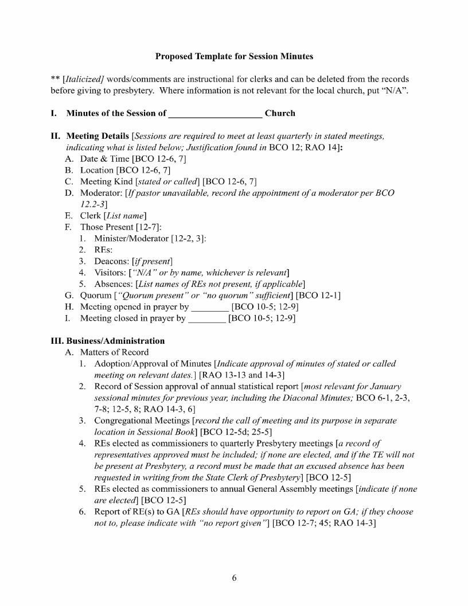

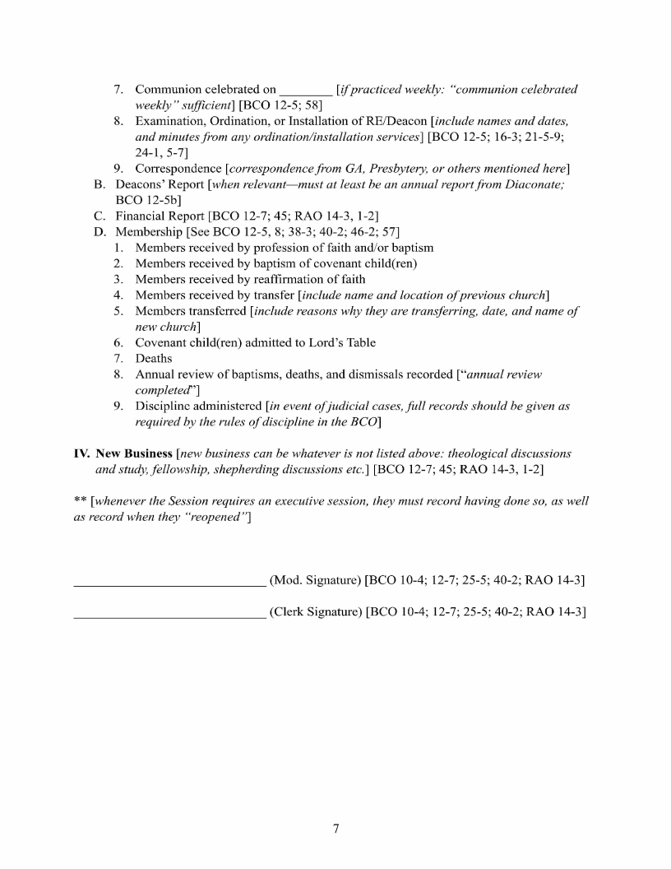

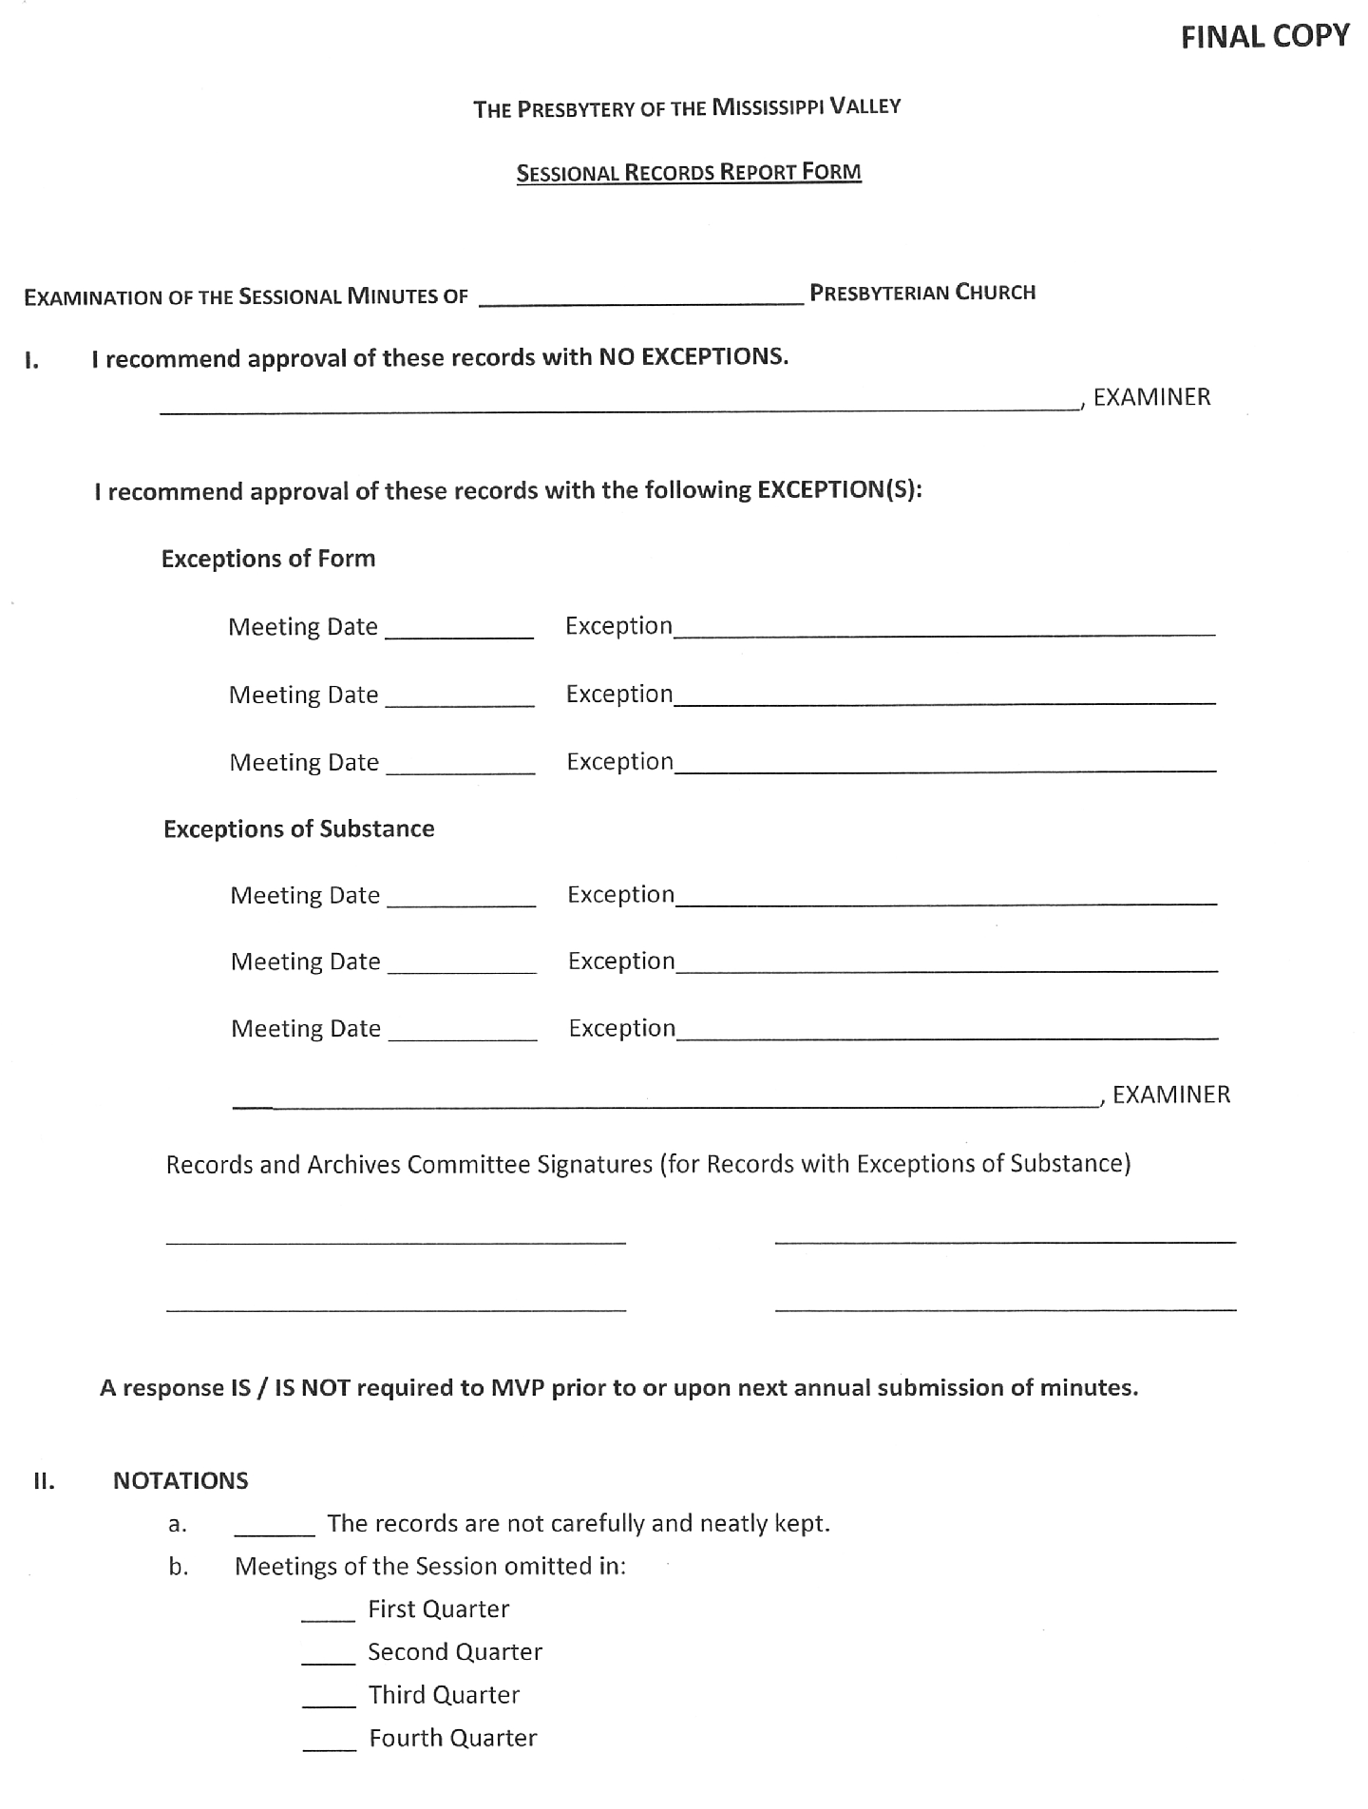

APPENDIX F

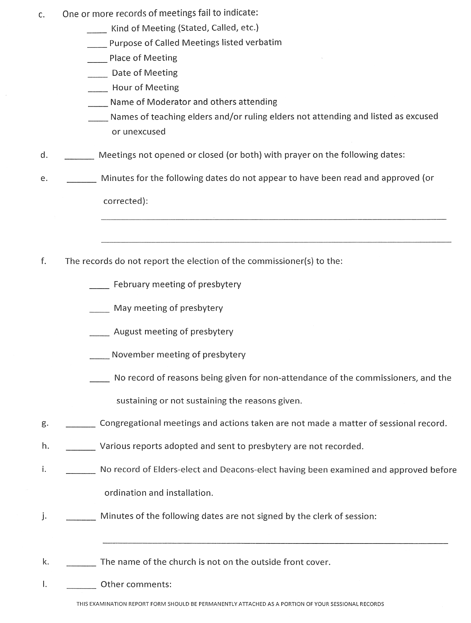

APPENDIX G
Strategic Goals Adopted February 11, 2003

CHURCH GROWTH AND VITALITY

1. To plant five PCA congregations in PMV within the next ten years (by 2012), which shall include either:
(a) an ethnic church, or
(b) a multi-racial church, or (c) the possibility of both.

2. To develop voluntary sister-church partnerships for the resourcing and encouragement of congregations, with the goal of revitalizing five PCA congregations within the next ten years (by 2012).

3. To promote and develop at least seven sister-church relationships between the PCA and African-American, Hispanic and other ethnic congregations in the next ten years (by 2012).

4. To promote and develop at least twenty sister-church relationships between PCA congregations and overseas congregations within the next ten years (by 2012). These may include several smaller PCA congregations combining together in partnerships.

5. To enable four PMV pastors or ruling elders per year to participate in an MTW Vision Trip overseas.

6. To pray for and seek out four singles or couples per year from our presbytery churches for short-term or career service.

7. To pray for and work toward more deliberate and aggressive conversion growth for PMV with the goal of 10% conversion growth within ten years (by 2012).

8. To initiate at least one PCA congregation near a U.S. military bas in a foreign country by January 1, 2012.
MNA

SHEPHERDING ADVISORY

MNA

MTW

MTW

MTW

MNA

MMC

DEVELOPMENT OF LEADERSHIP

1. To establish or adopt a Church-Planter Development Program for PMV (e.g. The Twin Lakes Fellowship).

2. To develop and implement a system for mentoring candidates and interns for the Gospel ministry that includes:
MNA

CREDENTIALS

a) Selecting the most qualified and gifted men for the ministry.

b) Attending to the spiritual health of a man’s marriage and family in preparation for ministry.

c) Developing an internship philosophy in complement to the BCO curriculum and goals.

d) Facilitating the matching of interns with congregations who either need or offer internships.

e) Cultivate proactive leadership by pastors and sessions to serve as the primary point of reference for the evaluation of calls to the ministry.

f) Cultivate a closer, synergistic working relationship with Reformed Theological Seminary in preparing men for the ministry.

g) Staff a liaison officer to oversee and coordinate the mentoring of candidates within PMV (training mentors, liaison with RTS, helping churches establish internships).

h) Recruit and mentor ethnic minorities for the Gospel ministry.

3. To develop and make available an officer training curriculum DM for PMV congregations and train teaching and ruling elders
in the use of said curriculum.

4. To promote resource and scholarship training for Church DM Elders, Ruling Elders and Deacons) in the principles and
practices of Church revitalization through: a. The Barnabas Institute
b. The Convocation of Reformation and Revival c. Embers to a Flame/Fanning the Flame
d. Other available revitalization ministries

5. To encourage and facilitate more participation by ruling elders in presbytery and General Assembly.

6. To provide pastoral oversight to all men in PMV who are without call or who labor out of bounds.

7. To provide ongoing support and oversight of PMV military church plants and chaplains.
DM

SHEPHERDING ADVISORY

MMC

DENOMINATIONAL UNDERSTANDING AND EFFECTIVENESS

1. To promote and develop stewardship commitments resources for the work of General Assembly and presbytery.

a. To develop a PMV website to include church web pages for all PMV churches, announcements, resources and distinctives.

b. To continue to work to make presbytery meetings more edifying and encouraging while continuing to conduct our necessary business.
ADMINISTRATION

ADMINISTRATION

ADMINISTRATION

ENGAGING THE CULTURE WITH REFORMED TRUTH

1. To creatively, systematically and strategically use mass media to project PCA distinctives, promote PCA mission and proclaim reformed positions on various issues: (e.g., the Presbyterian Hour Radio program, the use of PMV website, regular purchase of Clarion-Ledger news-space for commentary and editorial, etc.)

2. To identify and cultivate relationships with mercy ministries in our rural and inner-city areas of presbytery
(e.g. Neighborhood Christian Centers.)

3. To sponsor a PMV Worldview Conference every three years through presbytery’s Discipleship Ministries Committee.

4. To develop a Diaconal Ministries Committee for PMV, staffed by deacons of PMV congregations, to plan for, promote and resource mercy ministry for our presbytery.

ADMINISTRATION

MNA - DIACONAL

DM

MNA

